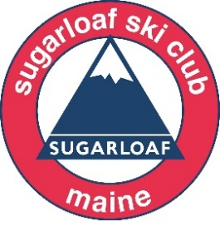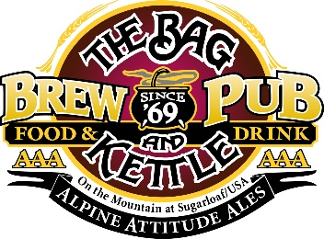

We hope you can join us at Sugarloaf for

THE 4ist ANNUAL SUGARLOAF SKI CLUB GOLF CLASSIC
Presented by The Bag and Kettle and The Sugarloaf Golf Club
Friday, June 24,2022
$600/Foursome includes: golf, cart, mulligan, lunch, all contests and raffle

The Ski Club Golf Classic offers a round of golf at the spectacular Sugarloaf Golf Course and the opportunity to help Maine youth. All proceeds from this event will support the Dick and Martha Ayotte Memorial Scholarship Fund.

Schedule:
Friday, June 24 One-Step Registration 7:30 am
Shotgun Start 9:00 am
Lunch & Awards at Strokes 2:30 pm

Register today at: www.sugarloafskiclub.org $600/Foursome $150/Individual

or print form and mail to: Sugarloaf Ski Club, 9008 Main St. Carrabassett Valley, ME 04947

Name 1.________________________________________________________________ H’cap______

email:_______________________________________________________________________________

Name 2.________________________________________________________________ H’cap______

email: _______________________________________________________________________________

Name 3.________________________________________________________________ H’cap______

email:_______________________________________________________________________________

Name 4.________________________________________________________________ H’cap______

email:_______________________________________________________________________________

I will be a Hole Sponsor $200_____ I will make a donation $ ______________

